**Test Plan**

**Objective:**

The objective of this test plan is to automate the testing of the Tags Input Box Component to ensure that it functions correctly and meets the requirements specified in the design and functionality sections. The automation coverage will include testing the component's default state, tags insertion, and tags deletion.

**Scope:**

This test plan covers the following areas:

* Default tags
* Tags insertion
* Tags duplication
* Tags removal

**Test Cases:**

**Default tags tests**

* Verify that the tags box contains the default tags "node" and "javascript".
* Verify that with default tags, only 8 tags remaining.

**Tags Insertion tests**

* Verify that the user can insert a tag by pressing the enter key.
* Verify that the user can insert multiple tags by adding a comma after each tag name.
* Verify that the tags length should be more than one character - Single insert.
* Verify that the tags length should be more than one character - Multi insert.
* Verify that the tags should not be duplicated - Single insert.
* Verify that the tags should not be duplicated - Multi insert.
* Verify that the maximum number of tags in the tags box is 10 - single insert.
* Verify that the maximum number of tags in the tags box is 10 - Multi insert.
* Verify that the remaining tags indication updates after inserting a new tag.

**Tags Deletion tests**

* Verify that the user can delete a default tag by clicking on the remove icon.
* Verify that the user can delete a tag after insertion.
* Verify that the "Remove All" button removes all the tags from the tags box - Default.
* Verify that the "Remove All" button removes all the tags from the tags box - After insertion.

**Results:**

Green-Passed tests, Red- Failed test with bug description

**Default tags tests**

* Verify that the tags box contains the default tags "node" and "javascript".
* Verify that with default tags, only 8 tags remaining.

**Tags Insertion tests**

* Verify that the user can insert a tag by pressing the enter key.
* Verify that the user can insert multiple tags by adding a comma after each tag name.
* Verify that the tags length should be more than one character - Single insert.
* Verify that the tags length should be more than one character - Multi insert:

When inserting multiple tags separated by comma, tags with length 1 or less are added:

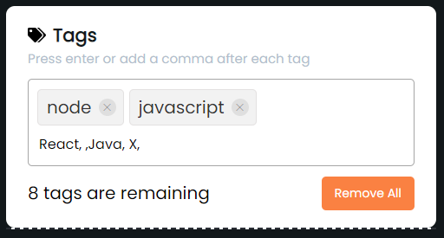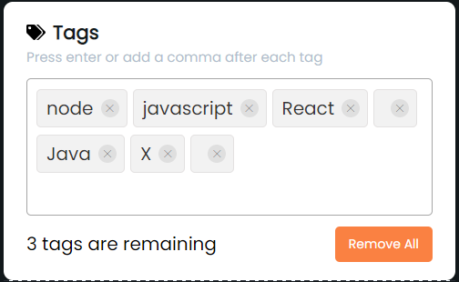

* Verify that the tags should not be duplicated - Single insert.
* Verify that the tags should not be duplicated - Multi insert:

When inserting multiple tags separated by comma, duplicate tags are added:

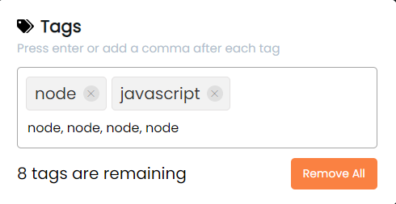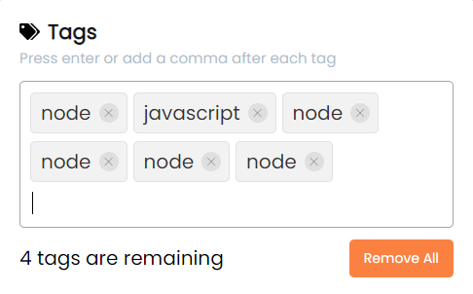

* Verify that the maximum number of tags in the tags box is 10 - single insert.
* Verify that the maximum number of tags in the tags box is 10 - Multi insert.

When inserting multiple tags separated by comma, more than the allowed maximum tag number are added:

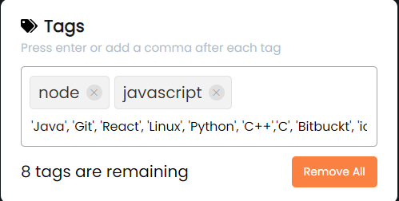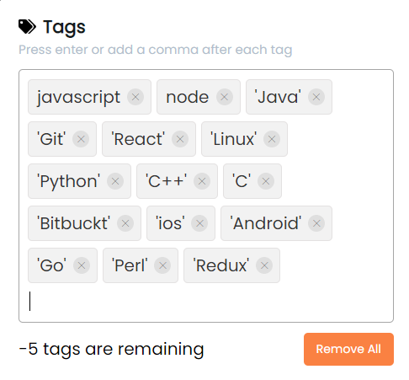

* Verify that the remaining tags indication updates after inserting a new tag.

**Tags Deletion tests**

* Verify that the user can delete a default tag by clicking on the remove icon.
* Verify that the user can delete a tag after insertion.
* Verify that the "Remove All" button removes all the tags from the tags box - Default.
* Verify that the "Remove All" button removes all the tags from the tags box - After insertion.

**Summery:**

Total test cases: 15

Passed: 12

Failed: 3

Bugs found: 3